Engineering Graphics Drawing Model Test

Name: Kunal Keshan S Date: 19th July 2021

Register Number: RA2011004010051

# 1. b) Draw the projections of a straight-line AB, 60 mm long parallel to HP and inclined at an angle of 40o to VP. The end A is 30 mm above HP and 20 mm in front of VP.

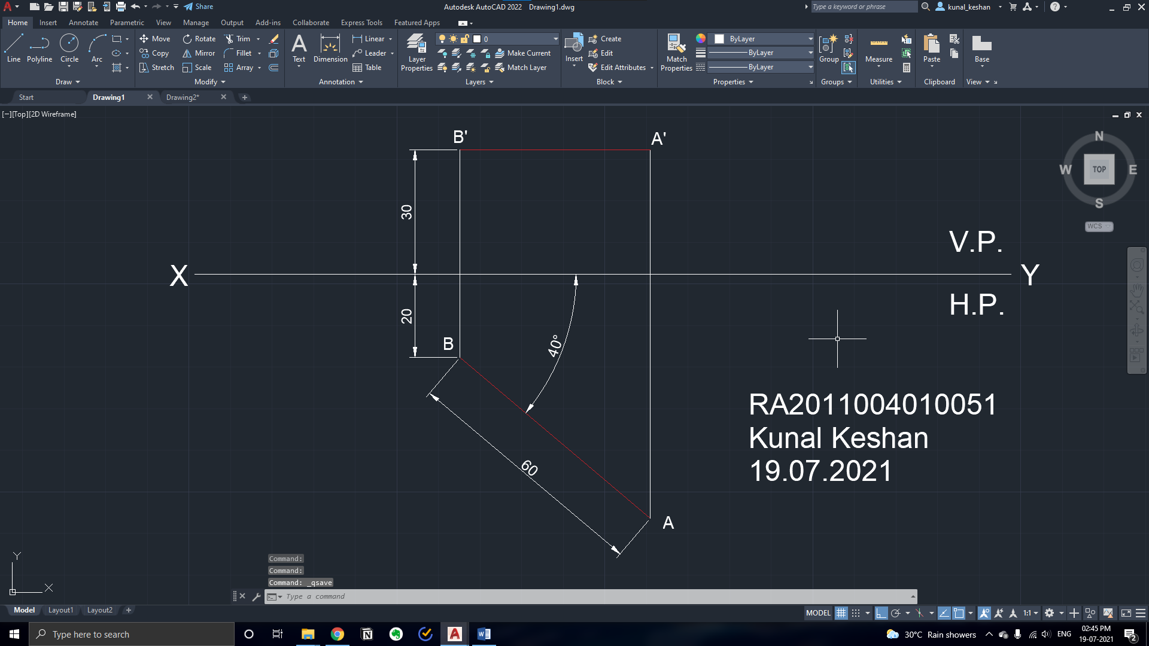

# 2. a) A pentagonal plate of side 30 mm is placed with one side on the HP and the surface inclined at 50o to HP and perpendicular to VP. Draw the projection of the lamina.

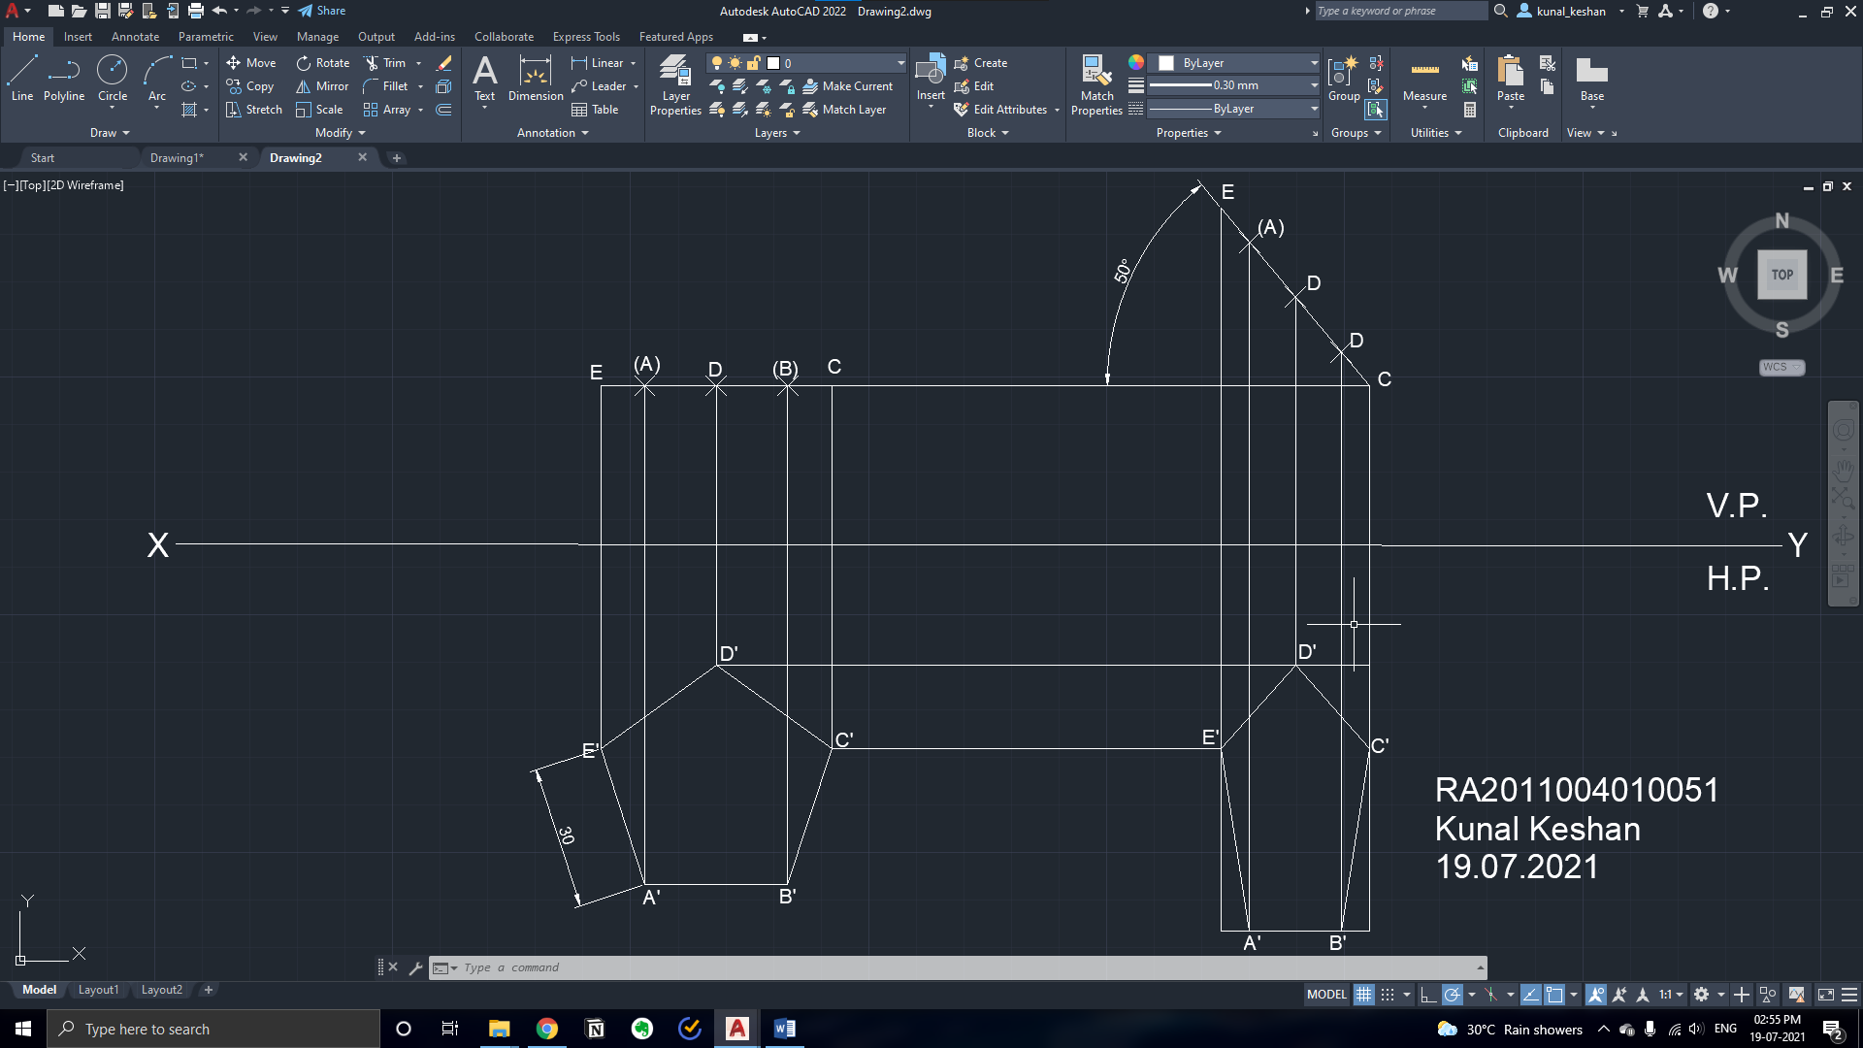

# 3. a) Draw the projections of a cylinder of 75 mm diameter and 100 mm long lying on the ground with its axis inclined at 30o to VP and parallel to the ground.

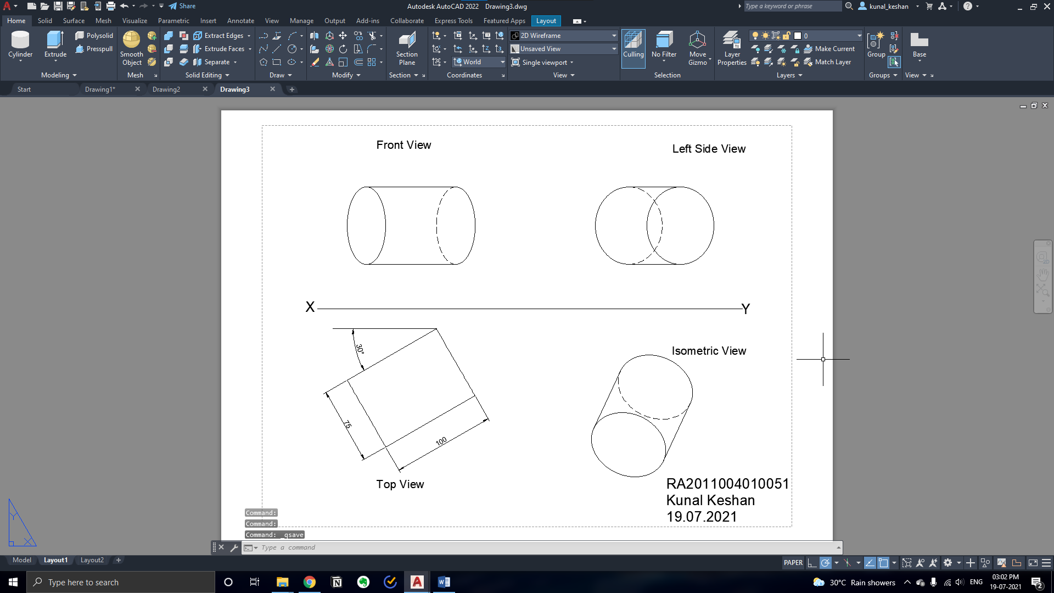

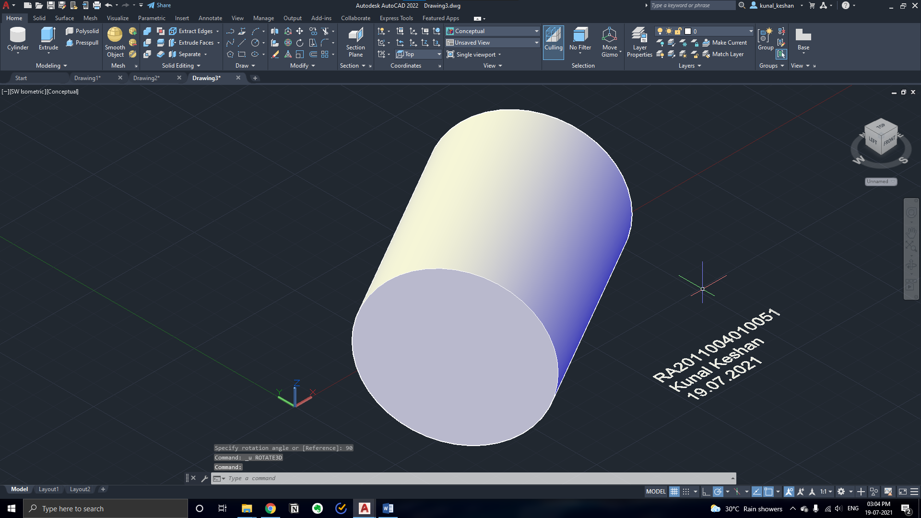

# 4. a) A pentagonal pyramid of base side 40 mm and axis length 80 mm is resting on HP on its base with one of its base side parallel to VP. It is cut by a plane inclined at 30° to HP and perpendicular to VP and is bisecting the axis. Draw its front view, sectional top view, and the true shape of section.

